Introduced by Council Member Becton and Co-Sponsored by Council Members Wilson, Gulliford, Crescimbeni and Ferraro and substituted by the Land Use and Zoning Committee:

ORDINANCE 2018-271-E
AN ORDINANCE REGARDING CHAPTER 654 (CODE OF SUBDIVISION REGULATIONS), ORDINANCE CODE, AMENDING SECTION 654.110 (PROCEDURE FOR APPROVAL AND RECORDATION OF FINAL PLAT) TO REQUIRE SATISFACTORY CONSTRUCTION OR GUARANTEE OF REQUIRED IMPROVEMENTS AS A PREREQUISITE TO APPROVAL OF PLAT, AND TO REQUIRE POST-CONSTRUCTION WARRANTY; AMENDING SECTION 654.111 (DESIGN STANDARDS: STREETS), TO CREATE A NEW SUBSECTION (O) TO REQUIRE A MINIMUM ROADWAY PAVING WIDTH OF 24 FEET FOR RESIDENTIAL SUBDIVISIONS IN CERTAIN ZONING DISTRICTS; AND TO CREATE A NEW SUBSECTION (P) TO REQUIRE ACCEPTANCE OF ALL NEW LOCAL STREETS IN DEVELOPMENTS TO BE IN A MULTI-STEP PROCESS; AMENDING SECTION 654.115 (DESIGN STANDARDS: ACCESS TO THE PUBLIC RIGHT-OF-WAY), TO REQUIRE NEW COMMERCIAL DEVELOPMENTS FRONTING COLLECTOR OR HIGHER FUNCTIONALLY CLASSIFIED ROADS TO PROVIDE FOR VEHICULAR INTERCONNECTIVITY THROUGH PARKING LOTS via cross-access DRIVES TO ADJACENT PROPERTIES, AND REQUIRING EXISTING DEVELOPMENTS TO COME INTO COMPLIANCE UPON SUBSTANTIAL ENLARGEMENT OR IMPROVEMENT; AMENDING CHAPTER 744 (STREET CONSTRUCTION REGULATIONS), SECTION 744.110 (STREET EXCAVATIONS; WORK IN RIGHTS-OF-WAY; PERMIT; VIOLATIONS, CIVIL PENALTIES, ENFORCEMENT AND ABATEMENT), oRDINANCE cODE TO REQUIRE WARRANTY FOR WORK TO BE COMPLETED IN THE RIGHT-OF-WAY; PROVIDING FOR PROSPECTIVE EFFECTIVE DATE; PROVIDING AN EFFECTIVE DATE.

BE IT ORDAINED by the Council of the City of Jacksonville:
Section 1. Amending Section 654.110 (Procedure for approval and recordation of final plat), Chapter 654 (Code of Subdivision Regulations), Ordinance Code. Section 654.110 is hereby amended to read as follows:
Sec. 654.110. - Procedure for approval and recordation of final plat.
(a) Title certification and real estate taxes. taxes. A final plat shall be accompanied by a title opinion of an attorney-at-law licensed in Florida or a certification by an abstractor or a title company, addressed to the City of Jacksonville and certified to a date within 30 days of submission, showing that record title to the land as described and shown on the plat is in the name of the person executing the dedication, if any, as it is shown on the plat and, if the plat does not contain a dedication, that the developer has record title to the land. The title opinion or certification shall also show mortgages not satisfied or released of record in accordance with F.S. § 177.041, other encumbrances, and a certificate from the developer's attorney, abstract company or the Tax Collector that taxes due and payable at, or prior to, the time the application for final approval or acceptance is filed have been paid.
(b) Ownership of improvements. Upon approval and recordation of the final plat and after the construction of required improvements has been inspected and approved by the City, JEA or other approving entity, ownership of the improvements shall vest in the City, except that:
(1) The title to the street lighting standards shall vest in the appropriate electric utility serving the area.
(2) The title to water and/or sewerage system improvements located within the territory covered by a certificate of public convenience and necessity issued by the State Public Service Commission shall vest in the holder of the certificate.
(3) The title to water and/or sewerage system improvements in areas not covered by certificates of public convenience and necessity shall vest in the JEA where the continuing services are to be provided by the JEA, except where the interest in titles has been expressly denied by the JEA.
(4) The public rights-of-way within the subdivision must be specifically accepted by the City for maintenance of the drainage collection system and roadways.
(c) Application. Application for recording of the final plat accompanied by an updated certification by the developer's attorney or abstract company or Tax Collector and statements by the owner or dedicator shall be submitted in writing to the Director. Fees as required for the review of final plats shall be paid to the Tax Collector and a receipt therefrom shall accompany the application. The Director shall process such application as provided in the Land Development Procedures Manual. The Director shall process an application for final plat as provided in this Section. The Land Development Procedures Manual and current City Specifications shall be updated as required to be consistent with this Section, and Sec. 654.111. The application must be accompanied by the following in order to be deemed complete:
(1) An updated certification by the developers attorney or abstract company or Tax Collector that taxes due and payable at, or prior to, the time the application for final approval or acceptance is filed have been paid, and statements by the owner or dedicator submitted in writing;
(2) Proof of the warranties required in subsections (d) and (e), below; and
(3) A receipt from the Tax Collector showing that the fees as required for preliminary and final plat review have been paid.
(d) Construction of required improvements, within, or directly related to a proposed plat; alternatives in lieu of completion of required improvements; warranties required. The developer shall comply with one of the enumerated alternatives. If alternative (2), (3) or (4) is used, it will include the cost of placing permanent reference monuments (PRMs), as required in this Chapter, together with the survey costs incident to their proper placement. A developer may extend, renew or substitute collateral described in paragraphs (2)—(4) one or more times; provided, that no extension or renewal thereof or substitute therefor shall have a maturity or expiration date later than the time for completion of the improvements. The time for completion of the improvements shall be approved by the Director.
If the required improvements, with the exception of the final wearing surface lift of asphalt on the local streets, have been constructed as indicated on the plat, the plat shall be approved pursuant to paragraph (1) below. However, in order to have a plat approved prior to the required improvements being satisfactorily constructed, the developer shall assure that the required improvements as depicted on a proposed plat and related approved engineering plans will be completed by providing a guarantee to the City in one of the three (3) forms outlined in paragraphs (2), (3) and (4) in this Section.
Additionally, a secured warranty period after completion of the required improvements (“Post-Construction Warranty Period”) and warranty (“Post-Construction Warranty”) is required after completion of the required improvements, whether constructed prior to platting or secured by the Guarantee, pursuant to subsection 654.110(e), below.
See Figure 1 and Figure 2 as follows for Flow Charts of the process for both public and private rights-of-way.

FIGURE 1- “Public ROW: Plat to ROW thru Warranty Process”
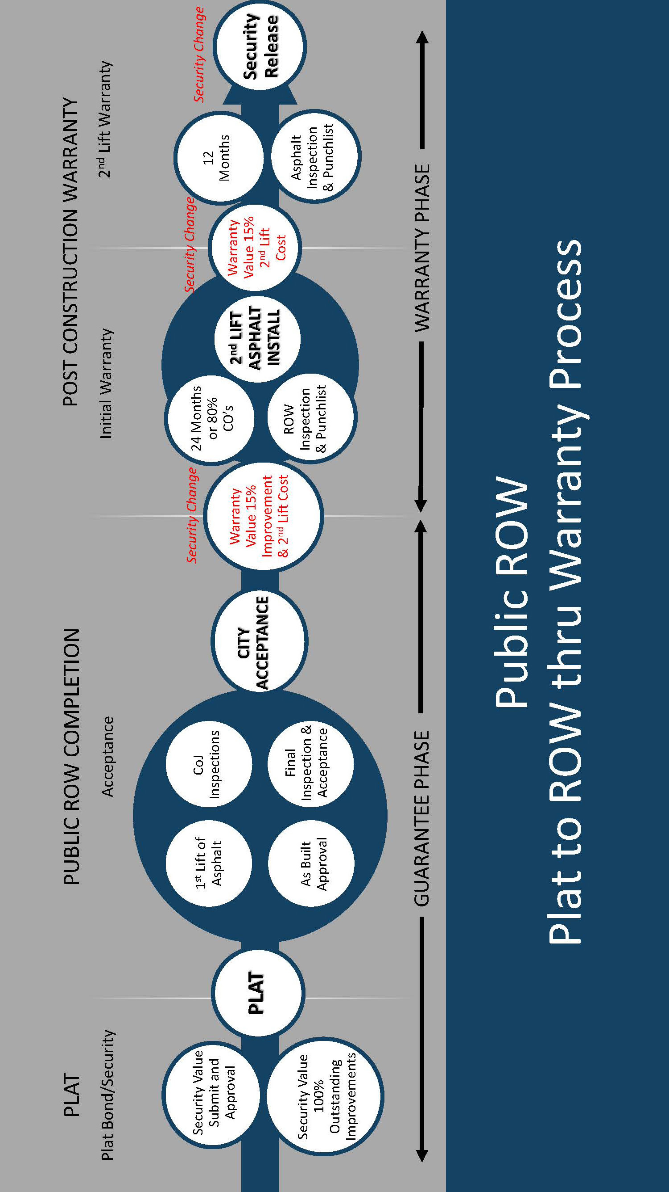

FIGURE 2- “Private ROW: Plat to ROW thru Warranty Process”
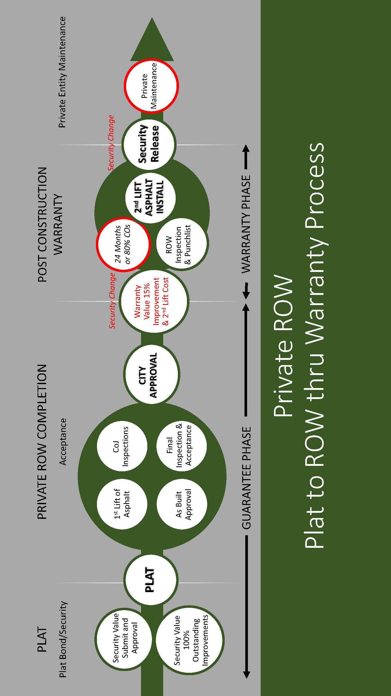

The amount of the Guarantee for the required improvements shall be equal to the total of the following: (1) one-hundred percent (100%) of the total cost of the remaining required subdivision improvements; (2) the cost of placing permanent reference monuments (“PRMs”) as required in this Chapter together with the survey costs incident to their proper placement; and (3) the costs to be secured by the Post-Construction Warranty, pursuant to subsection 651.110(e), below. Cost estimates for the required improvements shall be prepared, signed and sealed by a licensed Florida engineer and approved by the Director. The Director shall make a good faith effort to review and decide upon these cost estimates within fifteen (15) business days. The time for completion of the improvements shall be approved by the Director.
All work conducted outside of the proposed plat as part of the proposed development, when located within the City’s right-of-way, shall be subject to the security and warranty requirements of subsection 744.110(c), and shall be incorporated into one of the enumerated alternatives listed below.
(1) Construction of required improvements prior to plat. In the event the developer exercises the right to construct and complete required improvements prior to approval of the final plat, the City shall automatically become vested with the right to enter upon the property to be platted for purposes of inspecting the construction of improvements during the progress of the construction. The developer's engineer shall, upon completion of the entire work on one or more units of the subdivision, furnish the Director with a written certificate of the completion accompanied by the records and data as herein prescribed. If the Director finds that the completion of the required improvements complies with these regulations, the final plat shall be approved.
(2) Cash deposit. The developer shall deposit with the City or place in an account subject to the control of the City cash in the form of a certified check or cashier’s check. in the full amount of the total sum of the engineering and construction costs for the installation and completion of the required improvements. If the remaining estimated cost is $1,000 or less, the developer may provide a personal check.
The developer shall be entitled to secure draws from the deposits or account as installation progresses at stages of construction established by the Director but not more frequently than monthly. A draw from the case cash deposit or account shall be made only within may be made 30 days after the developer's engineer has certified to the City that the cost of improvements installed equals or exceeds the amount of the draw requested plus previous draws made and the Director has inspected the improvements and authorized the draw.
The Director shall have the right to reduce the amount of a requested draw to an amount he feels is justified based upon his inspection of the improvements and shall also have the right to refuse to approve a requested draw so long as the developer fails to be in compliance with any of the terms and conditions of the final plat or final engineering plans and specifications for the improvements.
The developer shall be entitled to receive interest earned on the deposit or account. The City, after 60 days' written notice to the developer, shall have the right to use the cash deposit or account for the completion of the improvements in the event of default by the developer or failure of the developer to complete the improvements within the time required by the Director.
(3) Letter of Credit. The developer shall furnish to the City a personal bond secured by an unconditional and irrevocable letter of credit issued by a state or national banking institution and in substantially similar form as approved by the Office of General Counsel and currently available on the Development Services website. in an amount equal to the total of engineering and construction costs for the installation and completion of the required improvements, which letter of credit shall be issued by a state or national banking institution to the City. The letter of credit shall be in the form approved by the Office of General Counsel. During the process of construction, the Director may reduce the dollar amount of the personal bond and letter of credit on the basis of work completed. The City, after 60 days' written notice to the developer, shall have the right to use any funds resulting from drafts on the letter of credit for the completion of the improvements in the event of default by the developer or failure of the developer to complete the improvements within the time required by the Director.
(4) Surety Bond. The developer shall furnish to the City a surety bond in the form and by a surety authorized to do business in the state and in substantially similar form as approved by the Office of General Counsel and currently available on the Development Services website, guaranteeing that, within the time required by the Director from final plat approval, the required work will be completed in full accordance with the final plat and all conditions attached thereto within the time for completion as approved by the Director from final plat approval., copies of which Copies of the plat and all conditions shall be attached to and constitute a part of the bond agreement. The bond shall be in an amount equal to 100 percent (100%) of the sum of engineering and construction costs.
During the process of construction, the Director may reduce the dollar amount of the bond on the basis of work completed. The City, after 60 days written notice to the developer, shall have the right to bring action or suit on the surety bond for the completion of the improvements in the event of default by the developer or failure of the developer to complete the improvements within the time required by the Director.
The final plat and any supplemental material shall be held in escrow by the Director until the developer has fulfilled all requirements of this Chapter and the Land Development Procedures Manual. Upon completion of all such requirements to the satisfaction of the Director, or his designee, and approval by the Director of the construction of all improvements; or in lieu thereof, the posting of security as provided in subsection (e) of this Section;, and payment by the developer of required plat recording fees to the Clerk of the Circuit Court;, the Director shall record the plat.
(e) Post-Construction Warranty. Upon the installation of the first-lift for local streets, a request may be made for acceptance of the required improvements depicted on the approved engineering plans for public local streets, and for approval for private local streets, that were secured by the Guarantee. The request shall be made by the person, firm or corporation seeking such acceptance (“Applicant”) who shall first furnish the Post-Construction Warranty acceptable to the City in an amount equal to fifteen percent (15%) of the total of all construction contracts issued for the required improvements that the City has accepted for maintenance (or in the case of a private local street the improvements that the City approved that a private entity will maintain), plus the cost to secure the application of the wearing surface course (final lift) as outlined in Section 654.111(p). This security may either be an amendment to the original Guarantee posted at time of platting, or may be a new certified or cashier’s check, an unconditional and irrevocable letter of credit, a surety bond, or combination thereof. If a new security is posted, the security supporting the Guarantee pursuant to Sec. 654.110(d)(2-4) will be returned and/or released at the time of as-built drawing approval.
The Post-Construction Warranty shall be furnished to secure, during the Post-Construction Warranty Period, at least the following: repair of the required improvements against faulty workmanship, construction and materials; damage done by agents of the Applicant to curb and gutter, asphalt pavement, drainage piping, structures or sidewalks; the application of the final wearing surface course, pursuant to subsection 654.111(p); and other required improvements as shown on the approved engineering plans. Said security shall be submitted by the Applicant, for both public and private subdivisions, to the City for approval and forwarding to the Director and shall remain in force until released as stipulated below.
If the Applicant or their agent takes no action to address any deficiencies, after a 60 days' written notice to the developer, the City may elect to repair and take remedial action to correct the deficiencies during the Post-Construction Warranty Period by drawing such cost from the security. The developer, owner, or assign shall provide evidence annually that the Post-Construction Warranty continues in force until such time that the Director authorizes its release and return.
Local streets that do not provide access to the abutting property may be exempted from the Post-Construction Warranty requirement by the Director.
(f) Reduction and Release of the Post-Construction Warranty.
Upon satisfactory application of the second lift, the Director shall reduce the amount of the Post Construction Warranty to 15% of the actual cost of the second lift (wearing course). The Director or designee shall make a good faith effort to review the application and inspect the second lift within fifteen (15) business days.
The Post-Construction Warranty shall be released twelve (12) months after the second lift is satisfactorily applied pursuant to subsection 654.111(p), in the applicable phase of the subdivision.
For private local streets, re-inspection and release of the Post Construction Warranty may be requested any time after the satisfactory installation of the final wearing surface course.
Section 2. Amending Section 654.111 (Design standards: streets), Chapter 654 (Code of Subdivision Regulations), Ordinance Code. Section 654.111, Ordinance Code, is hereby amended to read as follows:
CHAPTER 654. CODE OF SUBDIVISION REGULATIONS
* * *
Sec. 654.111 - Design standards: streets.
* * *
(n) The City shall require all new local streets projected to serve in excess of 1,600 vehicles per day and all new collector and minor arterial roadways to accommodate bicyclists within the roadway unless determined by the Department that such need does not exist.
(o) All new local streets in a residential subdivision that are adjacent and provide access to lots that are of a size allowed in a Residential Low Density – 60 (“RLD-60”) zoning district or smaller, including lots of that size or smaller within a Planned Unit Development (“PUD”) District, shall have a minimum paving width of twenty-four (24) feet, not including curb and gutter. The paving width may be reduced to twenty (20) feet if any of the following conditions are met for that section of the road:
(1) The land is zoned as a Traditional Neighborhood Development (“TND”) District, and an alley is provided relative to the street, then the dimensions for TND roadways shall apply;
(2) A minimum of five (5) on-site parking spaces, measured pursuant to Sec. 656.607, Ordinance Code, are provided on each lot;
(3) A minimum of one (1)off-site parking space for every three (3) lots is provided no further than three hundred (300) feet away from the furthest lot; or
(4) At least one side of the road shall be designated as “No Parking” with either signs, striping, curb painting, or a combination thereof, as approved by the Planning and Development Department.
(p) A two-lift pavement system with regard to application of the second asphalt lift (wearing surface) is required for all new local streets. Tack (prime) coat shall be required between multiple lifts. All infrastructure and the base course shall be constructed in accordance with applicable Subdivision Regulations and the warranty requirements of Section 654.110. The wearing surface course application shall be delayed in each phase (as shown on an approved development plan) of single and multi-family residential developments until either:
(1) Eighty percent (80%) of the units in that phase have received a Certificate of Occupancy; or
(2) Twenty-four (24) months have passed since the first Certificate of Occupancy was issued in that phase.
Section 2. Amending Section 654.115 (Design standards: streets), Chapter 654 (Code of Subdivision Regulations), Ordinance Code. Section 654.115, Ordinance Code, is hereby amended to read as follows:
CHAPTER 654. CODE OF SUBDIVISION REGULATIONS
* * *
Sec. 654.115 – Design standards: access to the public right-of-way.
* * *
(f) Access to nonresidential parcels. The following provisions shall be observed when providing access to nonresidential parcels:
(1) Where a nonresidential subdivision abuts or contains a designated major arterial a service drive shall be constructed to connect with the service drive of adjacent properties unless otherwise approved by the Director, or his or her designee. If adjacent service drives do not exist, construction of such drives shall be a credit used to offset and mitigate a development's traffic impact for the purposes of concurrency.
(f) Access to commercial and office use parcels. The Council finds that improvement of traffic circulation within and between office and commercial parcels of similar intensity along collector or higher functionally classified roadways is in the public interest for both the convenience and safety of the public on the roads and within the parcels. The Council further finds that rights of private property owners are of interest and should be balanced against the public interest in improvement of traffic circulation. To that end, the following provisions shall be observed when providing access to commercial and office use parcels, other than those within the Commercial Central Business District (“CCBD”), or as excepted herein:
(1) Where a commercial or office use development abuts or contains a designated collector or higher functionally classified roadway, a cross-access drive, lane or way (“cross-access”) shall be constructed to connect the properties adjacent to the collector or higher functionally classified roadway in order to provide for interconnectivity of traffic flow through and along parking lots and access roads leading to and from adjacent commercial or office use developments without the need to access the collector or higher classified roadway.
(A) If the adjacent site is developed and, in the opinion of the Planning and Development Department, cross-access is feasible, the owner or developer shall design and build the appropriate cross-access to the property line of the adjacent parcel.
(B) If the adjacent site is developed, but in the opinion of the Planning and Development Department, cross-access is not feasible at this time, the owner or developer shall design and designate on the site plan the location of future cross-access, but will not be required to construct the cross-access at the time of initial site development. The owner shall commit, in writing, to construct and allow cross-access at such time as the City determines that cross-access is feasible and desirable.
(C) If the adjacent site is undeveloped, the owner or developer shall design and build the cross-access to the property line of the adjacent parcel in anticipation of future connection when that site is developed.
(D) The minimum width of a vehicular cross-access shall be 24 feet.
(E) Existing commercial or office use developments in place on the date of adoption of this interconnectivity requirement that do not contain the interconnectivity as required by this Section, shall be brought into compliance with this requirement under the following conditions provided that a determination is made by the Director that such interconnectivity requirements do not impose an undue burden, as described below, on the affected property owners:
(i) When a new driveway connection permit is required for the existing development; or
(ii) When substantial enlargements or improvements to the existing development are undertaken. “Substantial” means within any three-year period, when the total cumulative renovation of existing development is equal to at least 50 percent of the assessed value of the lot improvements (including structures and parking and exterior areas but not the value of the land) on the start of the three-year period, according to the Property Appraiser, or the total square footage of a structure is expanded to 50 percent or greater, as well as any cumulative square footage expansions totaling 50 percent; or
(iii) When a 25% or greater increase in vehicle trip generation is attributable to the new development, as compared to the existing development, is documented.
(F) Parcels zoned CCG-2 shall not be required to connect to parcels within a zoning district other than CCG-2, but they shall be required to interconnect with each other. Similarly, parcels within a zoning district other than CCG-2 are not required to connect to a parcel zoned as CCG-2.
(2) The construction or erection of any barrier or obstacle which would prohibit access to the service cross-access drive from a site's major parking area or prohibit sharing access drives for interconnectivity with adjacent properties shall be prohibited. This provision is not to conflict with or exempt a developer from complying with landscape and tree protection regulations.
(3) Specific exemptions to, or abatement of, this provision may be granted by the Director, or his or her designee when one or more of the following conditions occur:
(A) physical or regulatory constraints on a currently developed property prohibit, as determined in consultation with the City Engineer, the construction of a service cross-access road drive which meets the City's design and clear zone standards.; or
(B) The parcel required to provide interconnectivity requests an abatement based upon the use of their property as particularly requiring security or privacy as a mandatory element of their business. When that use ceases, the requirement to provide the cross-access resumes, and the abatement ends; or
(C) The owner or developer can prove to the satisfaction of the Director that there was a lease, mortgage, or other agreement, related to the real estate parcel in question, in existence prior to April 4, 2018, that prohibits the developer or owner from providing the cross-access. For purposes of this abatement, the abatement ends at the conclusion of such an agreement’s full term.
(D) The Director determines that an affected property owner otherwise subject to the provisions of this Section would currently be subject to an undue burden if required to provide the interconnectivity. An “undue burden” shall be determined as follows:
(i) In the opinion of the City’s Traffic Engineer, the connection will create undue traffic conflicts;
(ii) In the opinion of the Director, the connection will create undue harm to protected trees;
(iii) In the opinion of the City’s Engineer, the elevation change between sites creates an undue engineering burden, or creates undue utility conflicts;
(iv) Any other burden expressed in writing by the Director stating the undue burden and the rationale for declaring the burden undue.
* * *
Section 3. Amending Sec. 744.110 (Street excavations; work in rights-of-way; permit; violations, civil penalties, enforcement and abatement), Chapter 744 (Street Construction Regulations), Ordinance Code. Sec. 744.110 (Street excavations; work in rights-of-way; permit; violations, civil penalties, enforcement and abatement) is hereby amended to read as follows:
Sec. 744.110 (Street excavations; work in rights-of-way; permit; violations, civil penalties, enforcement and abatement).
* * *
(c)(1) For work conducted in the right of way which is less than 1,000 linear feet in scope, or is not part of proposed off-site improvement associated with approved development, the applicant shall meet the following requirements for surety. The applicant for a permit required by this Section shall, at the time of applying for a permit, file or have on file with the Director of Public Works an annual surety bond, or shall provide either: (1) a cash deposit, or (2) an unconditional and irrevocable letter of credit, which shall be effective for one year in the penal sum of $5,000 in a form approved by the Office of General Counsel, so as to insure prompt payment of loss, damage, cost and expense that may be incurred by the City or an adjoining property owner in connection with the work, including cost of erecting and maintaining warning signals, barricades or other preventive measures to eliminate safety hazards and maintain traffic flow, by reason of the failure of the applicant to restore or repair damage to a public road, public right-of-way or public easement of the City or the failure of the applicant to comply with this Section and the conditions of the permit. The allowable forms of security are outlined further in subsection 654.110(d), Ordinance Code.
When the request is made for acceptance of the required improvements, the applicant shall provide security to the City, in one of the forms stated above, guaranteeing and warranting the workmanship and materials for a period of one (1) year from the date of completion of all work performed pursuant to the permit. (2) For work conducted in the right of way which is 1,000 linear feet or greater in scope, or is part of proposed off-site improvement associated with approved development, the applicant shall meet the following requirements for surety. The applicant for a permit required by this Section shall, at the time of applying for a permit, file or have on file with the Director of Public Works an annual surety bond, or personal bond secured by or either: (1) a cash deposit, or (2) an unconditional and irrevocable letter of credit, which shall be effective for one year, in the penal sum of $5,000 in the amount equal to one-hundred percent (100%) of the estimated total cost of the required improvements, as provided by the developer’s State of Florida licensed engineer and approved by the Director. The surety bond and the letter of credit shall be in a form approved by the Office of General Counsel, so as to insure prompt payment of loss, damage, cost and expense that may be incurred by the City or an adjoining property owner in connection with the work, including cost of erecting and maintaining warning signals, barricades or other preventive measures to eliminate safety hazards and maintain traffic flow, by reason of the failure of the applicant to restore or repair damage to a public road, right-of-way or easement of the City or the failure of the applicant to comply with this Section and the conditions of the permit. The surety bond shall be enforceable by and payable to the City. During the process of construction, the Director may reduce the dollar amount of the bond, allow draws from the cash deposit, and allow reduction of the penal amount of the letter of credit on the basis of work completed, but in no case shall the reductions allowed provide for less than 15% of the total estimated cost of the improvement as security for the City.
When the request is made for acceptance of the required improvements, the applicant shall provide security a general warranty to the City in the amount equal to fifteen percent (15%) of the actual total cost of the improvements, in a form approved by the Office of General Counsel, guaranteeing and warranting the workmanship and materials for a period of one (1) year from the date of completion of all work performed pursuant to the permit. The allowable forms of security are outlined further in subsection 654.110(d), Ordinance Code, and shall be enforceable by and payable to the City.
* * *
Section 4. Prospective Effective Date for changes to Sec. 654.110 and Sec. 654.111, Ordinance Code. The new requirements contained within this ordinance 2018-271-E regarding sections 654.110 and 654.111, Ordinance Code, shall not be enforced until sixty (60) days after the Effective Date of this ordinance, and all construction plans submitted for 10-set review to the Planning and Development Department prior to sixty (60) days from the Effective Date shall be reviewed based upon the previous version of the Ordinance Code.
Section 5. Effective Date. This ordinance, other than the sections listed above in Section 4 of this Ordinance, shall become effective upon signature by the Mayor or upon becoming effective without the Mayor's signature.
Form Approved:

/s/ Susan C. Grandin_____
Office of General Counsel
Legislation Prepared By: Susan C. Grandin
0000.doc

